CASE STUDY SUMMARY:
Development of Screening Tools for the Interpretation of Chemical Biomonitoring Data
Richard A. Becker¹, Sean M. Hays², Steven Robison³, Lesa L. Aylward⁴, Christopher R. Kirman⁵
1 American Chemistry Council, Washington, D.C.; 2 Summit Toxicology, LLP, Lyons, CO; 3 Procter & Gamble, Cincinnati, OH; 4 Summit Toxicology, LLP, Falls Church, VA,; 5 Summit Toxicology, LLP, Orange Village, OH

1. Provide a few sentences summarizing the method illustrated by the case study.
The concept of Biomonitoring Equivalents (BEs) [Hays et al,. 2008] was developed to permit interpretation of human biomonitoring results into a health risk context. Because biomarker data are typically expressed in units of biomarker concentration (e.g., ug/L urine), and risk-based benchmarks (such as Reference Doses [RfDs] or Acceptable Daily Doses [ADIs] or Tolerable Daily Doses [TDIs]) are typically expressed in units of applied dose (mg/kg-day), a direct comparison between the two cannot be made. The Biomonitoring Equivalent approach was thus developed. Figure 1 is a conceptual illustration of using forward dosimetry from RfD to derive a BE.
Figure 1. Illustration of forward dosimetry to derive a BE.
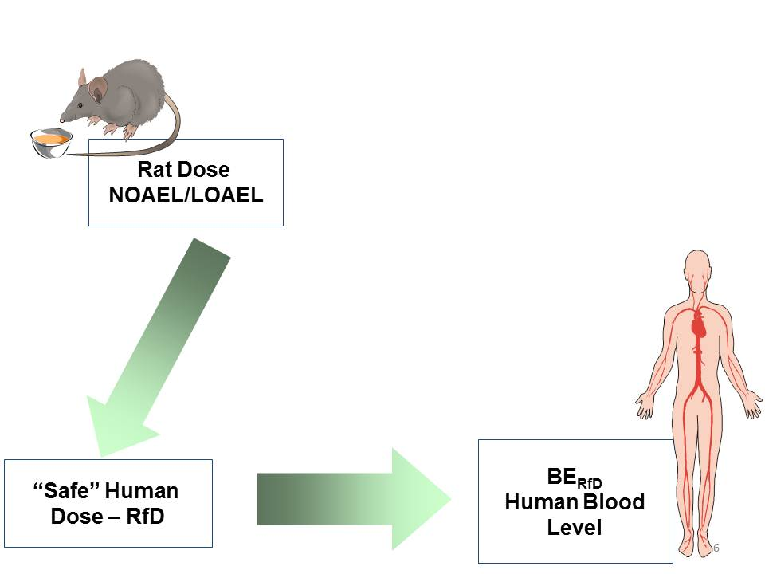
The Biomonitoring Equivalent approach translates the external dose health-based guidance value into the estimated corresponding steady state biomarker concentrations in blood or urine. A Biomonitoring Equivalent (BE) is defined as the concentration or range of concentrations of a chemical or its metabolites in a biological medium (blood, urine, or other medium) that is consistent with an existing health-based exposure guidance value such as a RfD or TDI or ADI [Hays et al., 2008]. BEs are intended to be used as screening tools to provide an assessment of which chemical exposures (biomarkers) are present at levels well below, near, or at or above concentrations that are consistent with existing risk assessments and exposure guidance values, and thus can provide an evaluation of relative priority for risk assessment follow-up.
In this case study we describe how the approach for using the Biomonitoring Equivalents (BEs) -- forward dosimetry to interpret human biomonitoring data in a risk context -- has been extended by the development of a framework with decision nodes to enable the BE approach to be applied to substances with varying degrees of toxicity data. The case study presents the framework and discusses its application for:
- A substance with government derived RfDs, ADIs, TDIs
- A substance with sufficient tox data (NOAELs/LOAELs) and toxicokinetic data or model but no government derived RfD
- A substance that lacks chemical-specific toxicokinetic data/model
- A substance that lacks both a tox guidance value and toxicokinetic data, but for which a class-based approach is supportable
- A substance with a derived Threshold of Toxicological Concern

2. Describe the problem formulation(s) the case study is designed to address. How is the method described in the case useful for addressing the problem formulation?
In the broadest sense, the problem that needs to be addressed is how to interpret human biomonitoring results to determine whether or not the exposures detected are of a magnitude that raises concerns for health. In absence of interpretation tools to understand human biomonitoring results some may equate the mere detection of a substance to impending illness or injury..
Now, with advanced analytical methods, it is now possible to quantitatively measure 10’s to 100’s of substances in reasonable sample volumes at the individual level. However, interpreting the results of human biomonitoring is challenging, even for well-designed and executed studies. Without tools to interpret biomonitoring results in a risk context, risk assessors and risk managers cannot distinguish the significance of the exposures, whether a result is of potential health concern or not, or whether the levels detected are so low as to be of no health concern whatsoever or whether the results signify that additional risk management or product stewardship actions may be warranted.
The concept of Biomonitoring Equivalents (BEs) was developed to permit interpretation of human biomonitoring results into a health risk context. Because biomarker data are typically expressed in units of biomarker concentration (e.g., ug/L urine), and risk-based benchmarks (such as Reference Doses [RfDs] or Acceptable Daily Doses [ADIs] or Tolerable Daily Doses [TDIs]) are typically expressed in units of applied dose (mg/kg-day), a direct comparison between the two cannot be made. The Biomonitoring Equivalent approach was thus developed. The Biomonitoring Equivalent approach translates the external dose health-based guidance value into the estimated corresponding steady state biomarker concentrations in blood or urine. A Biomonitoring Equivalent (BE) is defined as the concentration or range of concentrations of a chemical or its metabolites in a biological medium (blood, urine, or other medium) that is consistent with an existing health-based exposure guidance value such as a RfD or TDI or ADI [Hays et al., 2008]. BEs are intended to be used as screening tools to provide an assessment of which chemical exposures (biomarkers) are present at levels well below, near, or at or above concentrations that are consistent with existing risk assessments and exposure guidance values, and thus can provide an evaluation of relative priority for risk assessment follow-up.
BEs were designed to make maximal use of existing, authoritative (government) health guidance values (such as RfDs, ADIs, TDIs, etc.) that have been established through a transparent, scientifically rigorous process which included independent peer review. BEs derived from such health guidance values, once peer reviewed, can be applied to interpret human biomonitoring data in a health risk context with virtually the same certainty as the underlying health guidance value.
However, it is now apparent that approaches are needed to aid in the interpretation of human biomonitoring data for substances which lack such extensive and well vetted health guidance values. In addition, there are also cases where, although toxicity data may be available, robust toxicokinetic models are lacking, as well as cases where available data concerning both toxicity and toxicokinetics are limited.
The problem statement we sought to address was:
How can existing data and knowledge of toxicity and toxicokinetics be integrated to enable human biomonitoring results to be interpreted in a health risk context where available information can range from very complete to very sparse?
What would be a consistent and scientifically justified framework and associated decision criteria that could be applied to guide the development of such interpretation tools?
We proceeded to develop a tiered framework and decision tree (Figure 2) to guide the derivation of biomonitoring interpretation screening values which take into consideration the availability of different degrees of toxicity and toxicokinetic data.
Figure 2.. Framework for Developing Screening Values to Interpret Human Biomonitoring Data in a Risk Context (from Becker et al, 2011).
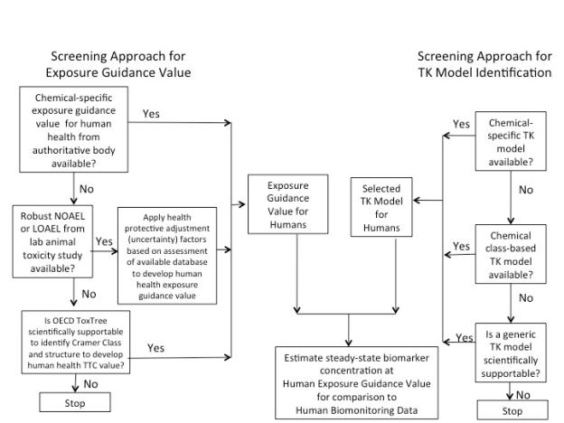

3. Comment on whether the method is general enough to be used directly, or if it can be extrapolated, for application to other chemicals and/or problem formulations. Please explain why or why not.
As described above and in the case study, by applying the framework, the use of forward dosimetry to interpret human biomonitoring data in a risk context can be widely used for substances with varying degrees of toxicity data and toxicokinetic information.
4. Discuss the overall strengths and weaknesses of the method.
BEs and the other biomonitoring screening values described in this case study can be used with biomonitoring measurements in a manner analogous to the way that RfDs or NOAELs or TTCs are used in evaluating potential human health risks from external exposures, since the BEs are simply external doses transformed to their corresponding internal concentrations. And, just as RfDs are not diagnostic of a disease or health state, neither are these biomonitoring interpretation values. BEs are not diagnostic medical biomarkers. BEs are not like serum cholesterol or serum liver enzymes, which have been shown through extensive scientific studies to be biomarkers indicative of (or correlated with) a specific health status or health outcome risk factor in humans. Similarly, RfDs are not medical diagnostic tools either. That said, RfDs have been used as decision tools in the evaluation of potential health risks to both individuals and populations, and BEs and related biomonitoring interpretation tools can be used in a similar manner.
The confidence one will have in the use of these approaches to interpret human biomonitoring data depends on the underlying confidence in the toxicity datasets and the toxicokinetic data or models used for a specific substance. There will be greater certainty when interpreting biomonitoring data for substances with extensive toxicity datasets and chemical-specific toxicokinetic data or models. When using class data or generic models, concerns can arise regarding domains of applicability, and these need to be evaluated prior to using such methods.
In addition to the data availability limitations, concern can arise when a BE is derived from a government health guidance value that is old, out-dated or otherwise inconsistent with current scientific best practices.. In such situations, the interpretation of the biomonitoring data may have the appearance of a high level of confidence or certainty, where in actuality, due to deficiencies in the underlying health guidance value, there is considerably lower confidence and greater uncertainty.
5. Outline the minimum data requirements and describe the types of data sets that are needed.
The framework and examples describe how the BE approach can be applied to substances with varying degrees of toxicity data and toxicokinetic information.
In considering the above points, consider the following specific issues as raised by the NAS (2008) report (Science and Decisions). The exact questions for consideration will depend on the problem formulation and nature of your case study. Addressing these issues will help the Panel evaluate your case study.
Does your case study:
A. Describe the dose-response relationship in the dose range relevant to human exposure?
Yes. The framework and examples describe how a BE approach can be used to interpret levels of chemical substances that have been detected in people.
B. Address human variability and sensitive populations?
Yes. For BEs based upon RfDs or ADIs, the derived BEs cover human variability and sensitive subpopulations in the same manner as the RfD or ADI. When other approaches are used to derive a screening level BE, then care must be taken to assure the population for which the interpretation of the biomonitoring data is to be applied is consistent with the populations covered by the derivation of the point of departure and populations covered by use of the specific toxicokinetic approach.
The confidence in the BE will be related to uncertainties associated with all the components of the science that underlie the BE derivation. The guidelines for development and communication of BEs [Hays et al., 2008; LaKind et al., 2008] discuss the confidence in chemical-specific BEs, noting that this requires consideration of the toxicity data, the understanding of ADME and mode of action that determines the relationship between the measured biomarker and the critical dose metrics related to adverse effects of the chemical, and the robustness of the pharmacokinetic data and models.
C. Address background exposures or responses?
Yes. The biomonitoring data themselves are a measure of the exposure arising from all sources, including background.
D. Address incorporation of existing biological understanding of the likely mode of action?
Yes. For BEs based upon RfDs or ADIs, the derived BEs reflect knowledge of MOA in the same manner as the RfD or ADI. Concern can arise when a BE is derived from a government health guidance value that is old, out-dated or otherwise inconsistent with current scientific best practices. In such situations, the interpretation of the biomonitoring data may have the appearance of a high level of confidence or certainty, where in actuality, due to deficiencies in the underlying health guidance value, there is considerably lower confidence and greater uncertainty. Therefore, it may be preferable derive a BE by using the more up to date scientific data and, if available, knowledge of mode of action, instead of using the out-dated government health guidance value.
E. Address other extrapolations, if relevant – insufficient data, including duration extrapolations, interspecies extrapolation?
Yes. The use of toxicodynamic and toxicokinetic components of Adjustment Factors is discussed.
For substances with toxicity database deficiencies, when deriving RfDs EPA has set a rule that the combined adjustment factor should not exceed 3,000 although some early EPA criteria were based on a total adjustment factor of 10,000. When deriving a BE for a substance with an incomplete toxicity dataset, if toxicokinetic components have been adequately accounted for, one could make the case that a MOS = 300 (which corresponds to a combined adjustment factor of 10X for toxicodynamics (TD) and 30X for database uncertainty) would provide the same degree of confidence as a MOS =1 for a substance with a rich toxicity database (where the adjustment factor is 10X for TD). [AF_{AH} = (3.16 TK x 3.16 TD); AF_{H} = (3.16 TK x 3.16 TD; AF_{DB}= 30]
F. Address uncertainty?
Uncertainty is discussed qualitatively. As some of the examples show, uncertainty and variability can also be addressed quantitatively when sufficient data are available.
G. Allow the calculation of risk (probability of response for the endpoint of interest) in the exposed human population?
Risk evaluation is presented for non-cancer endpoints, and the metrics used are Margin of Exposure and Margin of Safety. To date, a probability of response approach has not been explored for BEs for non-cancer evaluations.
H. Work practically? If the method still requires development, how close is it to practical implementation?
The case study and publications demonstrate the practical application of BEs for evaluating human biomonitoring results for non-cancer endpoints, and the metrics used are Margin of Exposure and Margin of Safety.

Available (open access) at http://www.biomonitoringequivalents.net/html/be_guidelines1.html

